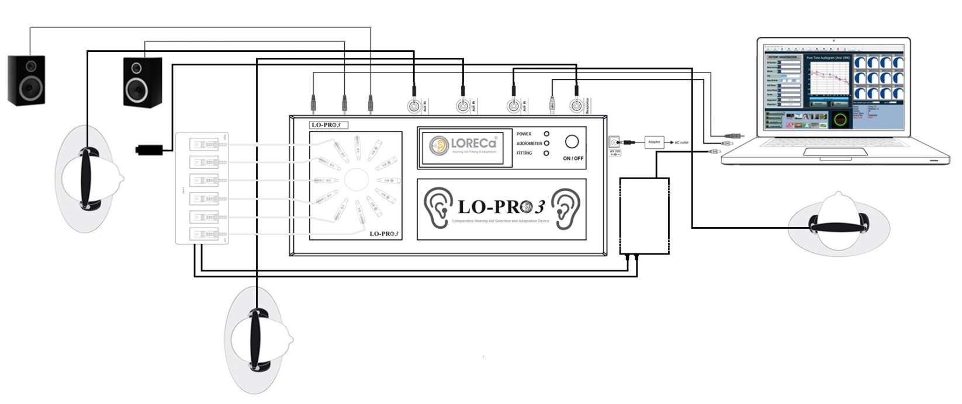

AUDIAL COMPARATIVE HEARING AID SELECTION AND ADAPTATION DEVICE

PRODUCT CODE:TR-003

Installation Guide (ENG)

© 2015 LO-PRO 3 , Doğuş Medikal Tic.ve San.Ltd.Şti. All rights are reseverved

Copyright Warning
This manual and any part of the programme cannot be reproduced without written permission of Doğuş Medikal Tic. ve San. Ltd. and cannot be saved at a protecting system and cannot be transferred in any way by electronical, mechanical devices and by means of photocopy, record and other ways.
Copyright © 2015, Doğuş Medikal Tic.ve San.Ltd.Şti.,
Publication Place: Turkey-Issuer: Doğuş Medikal Tic.ve San.Ltd.Şti., Turkey
All information, pictures and technical specifications in this manual are based on thye current information of the product during publication. The right of Doğuş Medikal Tic.ve San.Ltd.Şti.to make changes is reserved without giving information before.

Date of Version
2015-27-07

Technical support
Please get in touch with your supplier

Index Table

1.About Manual…………………………………………………………………..………………………………………………………………..4

2.Using Purpose………………………………………………………………………………………………..…………………………………….4

3 LO-PRO 3 Opening the pa………………………………………………………………………..……………………………………………….5

4 Installation and Necessary Measures to be obeyed ………………………………………………………………………………………………..5

5 Connection of accessories of Lo-Pro ………………………………………………………………………………..………………………… .5

6 Operating device……………………………………………………………………………………………………………………………………..6

12 Resolution of problems…………………………………………………………12

13 Description of symbols……………………………………………………13

14 Notes about EMC ………………………………………………….14

15 Service, Cleaning and calibration………………………………..…14

16 Other references………………………………………………………14

17 Notes for General warning……………………………………………………..15

18 Producer……………………………………………………………………16

ABOUT THIS MANUAL
This manual contains the instructions in direction of preparing to use and using of LO-PRO 3 Audial Comparative Hearing Aid Selection and Adaptation Device for users

Typographic Instructions

Using of instructions about Warnings, Attention
This manual contains the expressions and notes of warnings and attention suitably to use the device and/or software due to security, these headings are as follows;

Warning •Explains the harmful risks and Shows mortality and seriously injuring in terms of users or patients
Attention • Explains the current harmful risks, mortality and seriously injuring in terms of users or patients
Note• States you necessity to pay special atttention.

Warning ! This equipment can be connected to feeding network with protection of grounding in order to remove the risk of electric shock.

Attention ! Never use additional headphone and part not belonging to LO-PRO 3 device
(Directive of medical devices Item 12)

Note : Absolutely have the maintenance of your LO-PRO 3 device made every year.

Attention ! The parts (such as headphone bearings) directly contacting to the device should be disinfected every week

Attetion ! contains Electrical and electronical wastes and dangerous materials. Don’t throw away this kind of wastes together with municipality wastes due to this reason.

1-Description of Device
As you know, Selection of hearing aids for the patients with hearing loss is to facilitate the life of patient medically and socially and this product is a new device moderning the methods of selection of hearing aids and shortening the selection time and an innovative product developed to use at application centers and ear, nose and throat clinics.
LO-PRO 3 Audial Comparative Hearing aid Selection and Adaptation Device is a complete resolution designed to realize easy decision of audiometrists or audiologists and patients for the most suitable hearing aid to the dynamic field of ear, with the purpose of catching the real hearing effect of the one of about the most suitable hearing aid tried different 12 hearing aids cyclically settled on the panel of the device at the field of hearing health by means of its interface supported by software based PC.
Manual Trying hearing aides by conventional methods causes time loss and high economical cost because of extreme long trying time. One of the most typical faults is to be made of selection of hearing aides at silent mediums by being tried. The mediums where trying hearing aides are made are silent but we are not at so isolated mediums in daily life. LO-PRO 3 Audial Comparative Hearing aid Selection and Adaptation Device provides a resolution and facilities in understanding the speeches with hearing aides by forming various acustic mediums. Purpose is to provide a nice hearing and to discern despite of environmental noises.
LO-PRO 3 Audial Comparative Hearing aid Selection and Adaptation Device also has been solving the problems often met by implementers of hearing aides. While generally trying and advising hearing aides and implementers are telling the advantages and facilities of more expensive and digital hearing aides, they behaves extreme advertisemently and makes the patients distrustful and discontent. Trying and selection of hearing aid often turns to a long procedure of distrust and skeptisim. LO-PRO 3 Audial Comparative Hearing aid Selection and Adaptation Device is a modern resolution removing this problems like these too.
2- Purpose of using
LO-PRO 3 Audial Comparative Hearing aid Selection and Adaptation Device is a complete resolution providing facilities for many patients and implementersby its interface supported by software based PC and intends to solve the following negativities.
- It realizes for implementers (audiometrists or Audiologists) and patients to make decision easily for the most suitable hearing aid.
- It intends to provide the choosing the most suitable hearing aid by increasing the number of hearing aides tried by patients and applying similar and eternal combinations of hearing aid (HA) or Hybrid Hearing aides (CA+HA) at one ear or different combinations of BTE (Bejind The Ear (Right ear)-ITE in the ear (left ear), ITC in the concha (Right ear)-CIC in the channel (left ear).
- It provides trying hearing aides with different power and specifications for children and adults having mild, middle, middle advanced, advanced decree hearing loss at their right and left ears at the same time
- LO-PRO 3 provides the choosing the most suitable hearing aid producing the perfect sound guality by means of presenting sounds with real time on PC and being transmitted of the presented sounds output without any loss and addition in the form of passing through hearing aids in audial comparative method.
- LO-PRO 3 provides recording the data of trying hearing aides and audiogram information and getting output belonging to the patients by means of user interface software.

LO-PRO3 REAL TİME MULTIPLY HEARING AIDES SELECTION AND TEST DEVICE

EXPLANATION
This invention is related with trying and choosing real time, PC based, interactive digital hearing aid, by providing possibility to choose the most suitable hearing aid into the dynamic area of the ear in the passing to other digital programmable hearing aid to be tried, by presenting microprocesses based environment sounds (car sound, Bird sound, human sound, retaurant sound etc.) by means of headphone by operator aiming the chossing of the most suitable and correct hearing aid to the individual audiogram of the patient with hearing loss.
Previous technic:
Choice of hearing aid has been being made with conventional method on the present days by audiometrist. Choice and adaptation of hearing aid is realized by testing the decreased normal hearing range and loss of the patient with hearing loss.
The first step in choice and trying of hearing aid by conventional method is to choose type and model of hearing aid to be applied by checking audiogram test. The model of hearing aid is tried suitable to mild, middle and advanced hearing loss, being chosen by audiometrist, checking the frequency characteristics and pure sound level according to the test result of audiogram and hearing aid is presented to the use of the patient with hearing loss by being adjusted and programmed suitably to the patient whose hearing profile, wishes and needs are taken basis
Many hearing problems can be challenged by improved digital hearing aides on these days and a fulland active life can be maintained without giving any concession from way of life. Perfect suitability provided to patient by design, quality, fuction and performance of hearing aid is the important factor. To choose hearing aid by trying in various mediums is an effective method in understanding the performance of hearing aid
On these days, Analogue hearing aides, 100 % digital, Digital programmable and trimer hearing aides with different technical specification for different hearing loss are available in different brands. Audiometrists frequently tries to prove the quality levels of hearing aides with different specifications, at different prices to the patients with hearing loss, they behave extreme advertisely and causes distrust and displeasure against to implementer on patient with hearing loss, while they are telling the advantages and benefits of most quality and expensive digital hearing aides. For this reason, the trying and choice of conventional hearing aides is open to the considerable risks and falses
The choice and trying of hearing aid turns a long procedure forming with distrust and displeasure, fort his reason, due to lack of trust, purchase wish of hearing aid is broken or because of patients’ having no chance of trying many hearing aides in a short time, they stay compulsory to buy a tried hearing aid. At these both situation, the hearing healths of patients with hearing loss are effected negatively.
Real time Multiply Hearing aides Choice and test Simulator with its software supported by interface based PC is a complete resolution providing some facilities for audiometrists and patients with hearing loss.
Real time Multiply Hearing aides Choice and test Simulator has an operation specification independently from eachother, providing combination of multiply hearing aides placed on simulator device and provides being quick tested of hearing aides performances and to make decision quickly in choosing and pruchasing the most suitable device to the dynamic area of the ear in passing to another hearing aid from one.
Real time Multiply Hearing aides Choice and test Simulator can make applications of similar and eternal combinations of hearing aides at with the same or different brands and models at one ear or different combinations of BTE (Bejind The Ear (Right ear)-ITE in the ear (left ear), ITC in the concha (Right ear)-CIC in the channel (left ear) on the circle hearing aides panel.

It intends to provide the choosing the most suitable hearing aid (HA) or Hybrid Hearing aides (CA+HA) for using on one ear or two ears.
Real Time Multiply Hearing aides Choice and Test Simulator provides possibility and benefit to test various combinations by means of presenting sounds with real time on PC with connection software interface to the loudspeaker placed in Simulator with the headphone used by patient with hearain loss connected to Simulator device and being transmitted of the presented sounds output to the headphone used by the patient with hearing loss without any loss and addition by means of circuit in the mainboard of the Simulator.
Brief Explanation of Invention:
Purpose of this invention is to realize for both audiometrist and patient with hearin loss to make decision which hearing aid tried is useful.
Other Purpose of this invention is to realize showing of technical information tried by audiometrist and documenting the most useful system.
Another purpose of this invention is to realize providing information regarding to introducing which hearing mediums are preferred by patient with hearin loss for audiometrist.
PC SECTION (SOFTWARE)
Preliminary Opening screen
Start with Picture 1, during this time, other files being necessary to operate are prepared.
Instal the programme by setting up,
LO-PRO 3 Audial Comparative Hearing aid Selection and Adaptation Device is a complete resolution providing facilities for many patients and implementers by its interface supported by software based PC and intends to solve the following negativities.
- It realizes for implementers (audiometrists or Audiologists) and patients to make decision easily for the most suitable hearing aid.
- It intends to provide the choosing the most suitable hearing aid by increasing the number of hearing aides tried by patients and applying similar and eternal combinations of hearing aid (HA) or Hybrid Hearing aides (CA+HA) at one ear or different combinations of BTE (Bejind The Ear (Right ear)-ITE in the ear (left ear), ITC in the concha (Right ear)-CIC in the channel (left ear).
- It provides trying hearing aides with different power and specifications for children and adults having mild, middle, middle advanced, advanced decree hearing loss at their right and left ears at the same time
- LO-PRO 3 provides the choosing the most suitable hearing aid producing the perfect sound guality by means of presenting sounds with real time on PC and being transmitted of the presented sounds output without any loss and addition in the form of passing through hearing aids in audial comparative method.
- LO-PRO 3 provides recording the data of trying hearing aides and audiogram information and getting output belonging to the patients by means of user interface software.

3. Opening the package

- Please carefully open the package of LO-PRO 3 Audial Comparative Hearing Aid Choice and Adaptation Device when taking device and accessories out of package, it is a good ideas to keep package and other materials. If it is necessary for the device to send to service, original package provides protection against to damage during transport , handling etc.

2. Please check LO-PRO 3 Audial Comparative Hearing Aid Choice and Adaptation Device for possible damages by your eyes. If any damage is avaliable, don’t operate the device and get in touch for support with your local distributor.

3. Please check the package list of LO-PRO 3 Audial Comparative Hearing Aid Choice and Adaptation Device to be sure of having taken all necessary parts and accessories out. If the deficiency is available according to your package list, get in touch for support with your local distributor.

The following materials are available in the package of LO-PRO 3 Audial Comparative Hearing Aid Choice and Adaptation Device:
Product |  | Quantity | Reference No
LO-PRO 3 Audial Comparative Hearing Aid Choice and Adaptation Device |  | 1 Piece | 55001
LO-PRO 3 ,User interface software (CD Installation) |  | 1 Piece | 55002
LO-PRO 3 ,Flexi PCB Battery Contact (10A,312,13,675) | 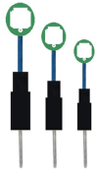 | 1 Set (12) | 55003
LO-PRO 3 , Sound Access Connection Aparatus |  | 1 Set (12) | 55004
LO-PRO 3 , Sound Access Cancel Aparatus  (Metal Nut) |  | 1 Set (12) | 55005
LO-PRO 3 , (Power) Adaptor | 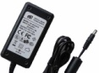 | 1 Piece | 55006
X-PRO Hearing Aid Cable Multiplier  (12 Cables Connection) | 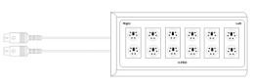 | 1 Piece | 55007
LO-PRO 3 , Installation and Using Manual |  | 1 Piece | 55008
LO-PRO 3 , Patient Reply Button | 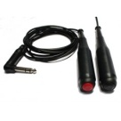 | 1 Piece | 55008

External Accessories dependant demand for LO-PRO 3 Audial Comparative Hearing Aid Choice and Adaptation Device
Product |  | Quantity | Reference No
Headphone (Quality dependant to wish) | 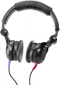 | 3 Pieces | 55010
Loudspeaker (for medium sounds in room) |  | 4> Pieces | 55011
Programming unit for Hearing aides (USB-Hi-PRO) | 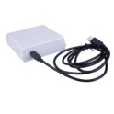 | 1 Piece | 55012
Programming cable for hearing aides (BTE,İTE,CİC,IC) | 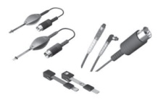 | 1> Piece | 55013
Battery for Hearing aides (10A,312,13,675) | 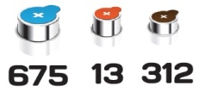 | 1> Piece | 55014

LO-PRO 3 Audial Comparative Hearing Aid Choice and Adaptation Device consists of PC user Interface Software (CD Installation), Flexi PCB Battery Contact (10A, 312, 13, 675), Sound Access Connection Aparatus, Sound Access Cancel (closing) Aparatus, X-PRO Hearing Aides Cable Multiplier (12 Cables Connection), Audial Comparative Hearing Aid Choice and Adaptation Device, a piece Headphone and user manual. Other external accessories used for Audial Comparative Hearing Aid Choice and Adaptation Device are supplied in return of cost.

4- Installation and Measures Necessary To Obey

LO-PRO 3, Audial Comparative Hearing Aid Choice and Adaptation Device is placed on a suitable table. The Thing you should do is to follow and to apply the range of instructions stated in user manual.

Recommended System Specifications for Our Programmes to Operate at High Speed are as follows;

Pentium IV 2.0 and over processor, Windows XP, Vista, Windows 7 operating system (1 GB - 32 bit ve 2 GB - 64 bit), (Windows XP and over operating systems are recommended) 512 MB Ram, 1 GB boş disc area

LO-PRO 3 Software Installation (Installation with CD)

The details in direction to follow the range about processes to install LO-PRO 3 are stated in this document. LO-PRO 3, Moreover, Set up files to be used for loading the programmes can be downloaded form the web site www.dogusmedikal.com.tr.
Open CD Installation File and start to install.

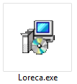  Tick the Icon and follow the instructions stage by stage until completing the configuration.  Figure 1: Installation Beginning | 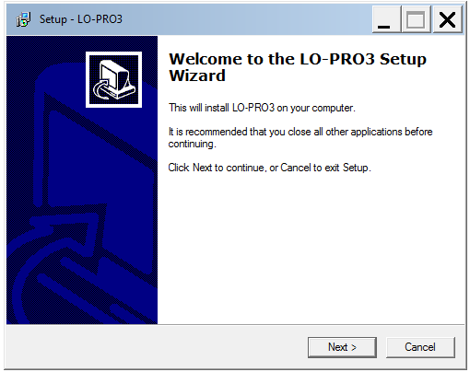  Tick the forward and follow the instructions stage by stage until completing the configuration.  Şekil 2: Installation Permit

Tick the forward and follow the instructions stage by stage until completing the configuration.  Şekil 3: Choosing Installation Range | Tick the forward and follow the instructions stage by stage until completing the configuration.  Şekil 4: Choosing the menu file of start

Tick the forward and follow the instructions stage by stage until completing the configuration.  Şekil 5: Choose additional duty | Tick Load and follow the instructions stage by stage until completing the configuration.  Şekil 6: Ready to Load

Loading is keeping on, wait until process is end  Şekil 7: Installation Progressing | Finish,Your computer will be restarted  Şekil 8: Installation ended.

All replies except for Error taken from Connection test shows the operating system. Operate LO-PRO 3 Programme form loaded range. It is necessary to operate the programme as operator at Windows Vista and Windows 7 operating systems, you can provide this by coming on the programme and ticking the right and choosing operate as operator.

Data of patients recorded at LO-PRO 3 are in the excell format. Don’t forget regularly to take spares every month. All data in the local disc are deleted, when the system goes up. Please tow the important information before going up. Previously loaded softwares will be slow, when the disc section is started for the first time. Please wait for a while. The system speed will turn to normal when it is opened for the second time.

5. LO-PRO 3 Audial Comparative Hearing Aid Choice and Adaptation Device

Front Panel
Position Lights named LED indicating the situation of the device are on the front panel.
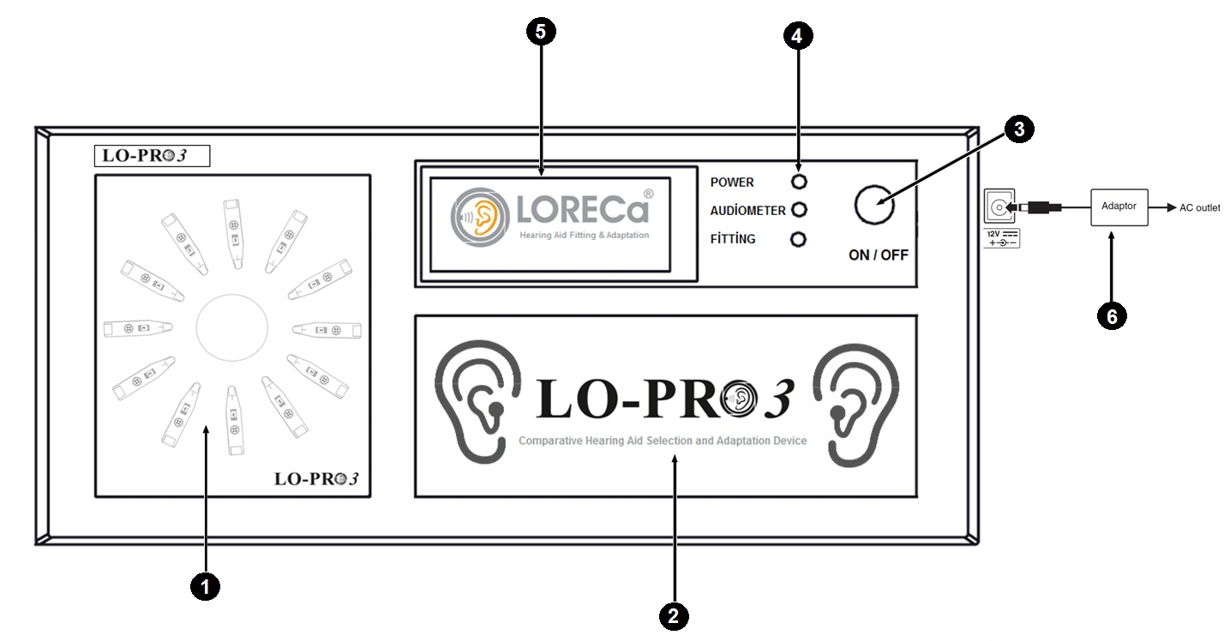
Cyclical Hearing Aids Panel (12 Pieces Hearing Aides can be placed)
Advertisement Section
On/ Off (Opening/closing) Key
Active Section Indicator (Power,Audiometer,Fitting)
Advertisement Section
Adaptor Access

Back Panel
Ports containing data and power connections of the device are in the back panel.
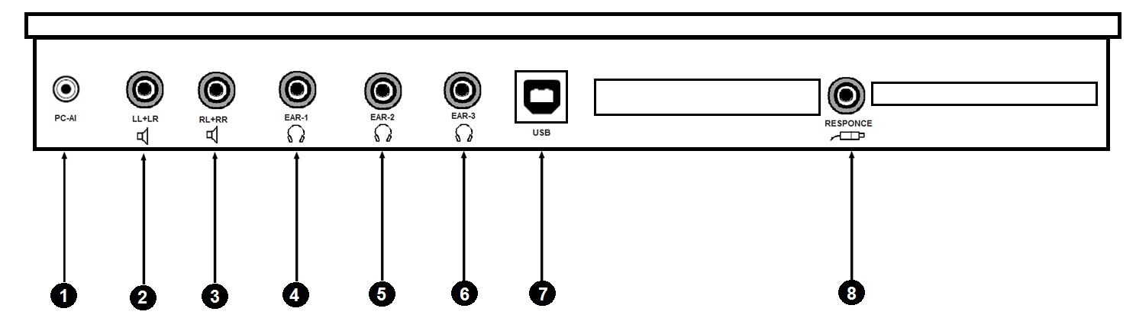
PC Sound Access
Loudspeaker 1 (Free Section)
Loudspeaker 2 (Free Section)
Headphone 1 (Clinician)
Headphone 2 (Patient With Hearing Loss)
Headphone 3 (Kin of Patient with hearing loss)
Computer USB Connection Access
Patient Reply Button

Data Storing by PC-User Interface Software

Cyclical Hearing Aides Panel
The pump EA 87 can be controlled maunally in addition to automatic mode. At this mode Pressure increase/decrease is controlled by buttons on the front panel.
X-BOX Hearing Aides Cable Multiplier (12 Cables Connection)
X-BOX Hearing Aides Cable Multiplier is the best invention realized Hearing Health Sector. X-BOX Hearing Aides Cable Multiplier has been designed to use to remove the time loss in trying different brands and models as well as to help programming cables hinder from damage.
X-BOX , keeps programminig cables of hearing aides, can be mounted on, under the table or on the wall. 36 Pieces Programming cables Set can be fixed by connection of 3 pieces X-BOX to eachother by consecutive usage, provides easy posiibility of cable choosing and labelling. The tips on the right and left panel are seperated by colour code. It provides the possibility of groupping hearing aides according to their powers and manufacturers.
Flexi PCB Battery Contact (10A, 312, 13, 675)
One of the most important parts of LO-PRO 3, Audial Comparative Hearing Aid Choice and Adaptation Device is flexi PCB Battery Contact. Flexi PCB Battery Contact provides to operate the hearing aides as well as makes the duty of key while passing to one hearing aid from another one. Three type battery have been developed such as 10A,(312-13) ve 675
Pure Sound Audiometry Test
Another one of the most important specifications of LO-PRO 3, Audial Comparative Hearing Aid Choice and Adaptation Device is basic air way Pure Tune Audimetry Specification. Record can be made by loading audiogram data of the patient with hearing loss. This is a supplementary specification limiting maximum output power with the purpose of control of patient’s hearing at the time of trying hearing aid.
Printer Connection
All the data belonging to the application with LO-PRO 3, Audial Comparative Hearing Aid Choice and Adaptation Device can be printed on A4 paper by option of print on the PC-User Interface Software.
5. Connection of Device

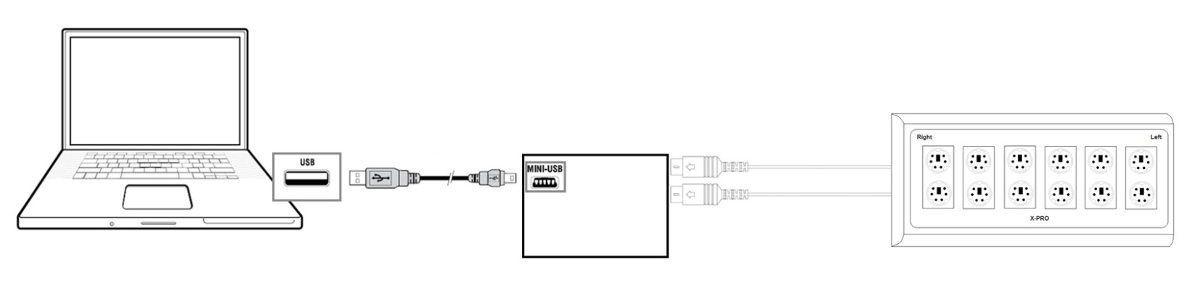
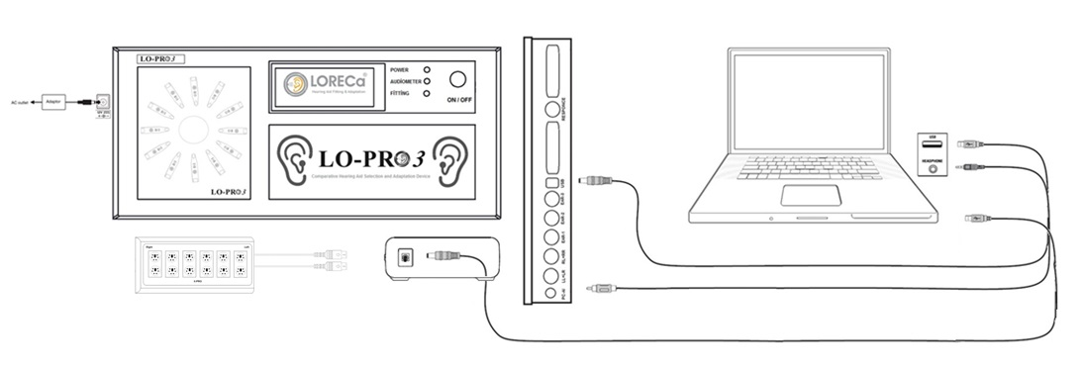

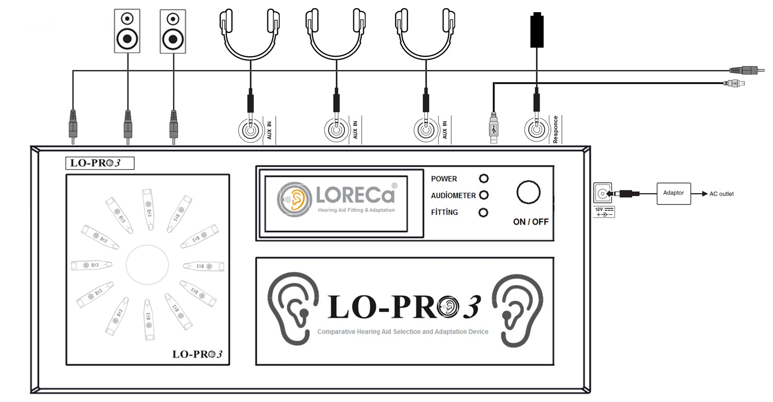

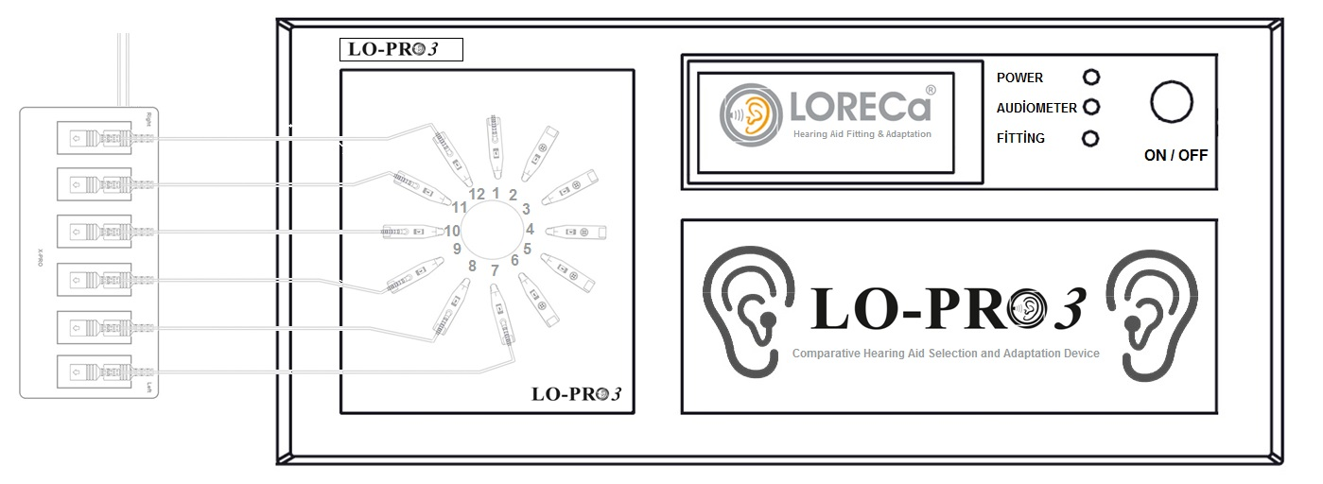

5. Trying Hearing Aides with LO-PRO 3

To be able to try heaaring aides with LO-PRO 3, Audial Comparative Hearing Aid Choice and Adaptation Device, the following basic actions should be done:

- Being placed of Hearing Aides onto the panel of cyclical Hearing Aid Panel

Cyclical Hearing Aides panel has the capacity of 12 pieces hearing aides. As You can try two hearing aides, at the same time you can try 6, 12 pieces hearing aides. Thing you should pay attention is to close sound exit tubes into which hearing aides are not connected by metal nut. You can try hearing aides (BTE,İTE,İTC,CİC) in different types at the same time as shown below. As you can make grouping the hearing aides according to the suitable power and efficiency, you can formulate them according to channel number.

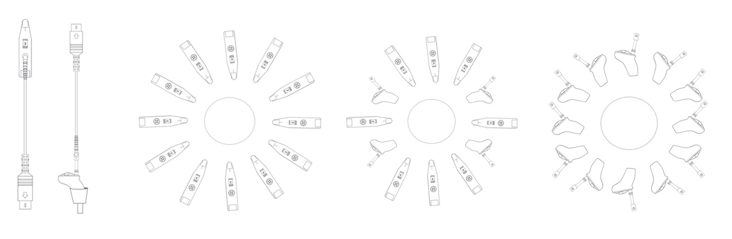

- Being prepared Hearing Aides ready to operate by Flexi PCB Battery Contact (10A,312,13,675)
One of the most important parts of LO-PRO 3, Audial Comparative Hearing Aid Choice and Adaptation Device is flexi PCB Battery Contact. Operation of Hearing Aides are provided by flexi PCB Battery Contact connected to main board integrated, flexi PCB Battery contact makes the duty of keying while passing to one hearing aid from another one. Three type batteries such as 10A,(312-13) ve 675 have been developed for this process.

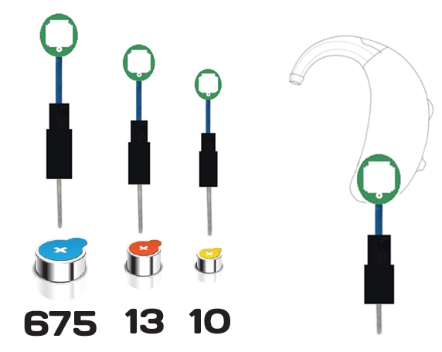

2.Being Organized of Hearing Aides Programming cables by X-Pro

X-BOX , keeps hearing aides peogramming cables. It can be mounted on, under the table or on the wall. 36 Pieces Programming cables Set can be fixed by connection of 3 pieces X-BOX to eachother by consecutive usage, provides easy posiibility of cable choosing and labelling. The tips on the right and left panel are seperated by colour code. It provides the possibility of groupping hearing aides according to their powers and manufacturers
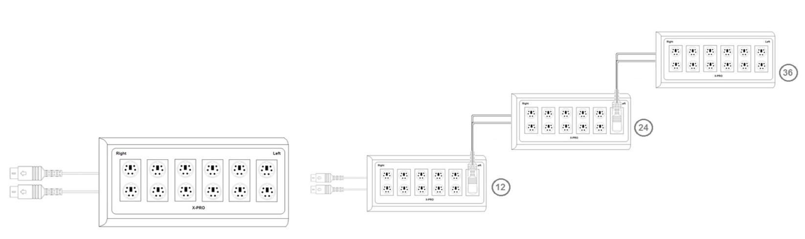
3.Inserting headphone to the patient with hearing loss and explanation of making trial

4.Trial and Choice of Hearing Aid
You can test hearing aides by using OTO suite HIT module when you placed hearing aides.
See making Standard Test ► 15 or you can make fitting based cups explianed in the document of AURICAL FreeFit ve Prop loudspeaker Measurements

Making Standard Test
Procedur
1.Start fitting software belonging to hearing aid in order to control Parameters.
2. Start OTOsuite and Choose HIT on the panel of surfing.
3. Open Test Chooser and choose ANSI or IEC special test.
4. If OTOsuite is used without having Noah , you can fill the areas of hearing aides on the right corner of Standard Tests Screen.
When you use OTOsuite together with Noah and fitting software belonging to hearing aid, these areas are automatically filled
5. Get hearing aid ready to test and open.
6.If you want the level of battery consumption, be sure of connecting to battery simulator
7. Open the close.
8. If necessary, tick Ok buttons on the table of measurements in order to add tests you wish.
9. Tick Start button on the left corner of measurement table, then chosen test processes are started.
10. Be sure of following the instructions on the screen.
11. If you want to renew a definite test, tick start beside the test.
Classical Behind The Ear Hearing Aides
This procedure,is valid fort he types of Behind The Ear Hearing Aides in all standards having classical ear moulds.
Hearing Aides with Thin Hose
This procedure type, is valid for all hearing aides with thin hose including (RIE) Receiver in the Ear / (RIC) Receiver in the channel and ones having prebented hoses
ITE Hearing Aides
This procedure, is valid for all personal hearing aides including ITE (In The Ear), ITC (In the Channel), CIC (Completely in The Channel).
Hearing Aides With Vendor without Cable (e.g. FM)
While hearing aides having sound transmittence without cable are tested, Vendor should sometimes be seperated from receiver

5.ILLUSTRATION of the features of Hearing Aides and Printing

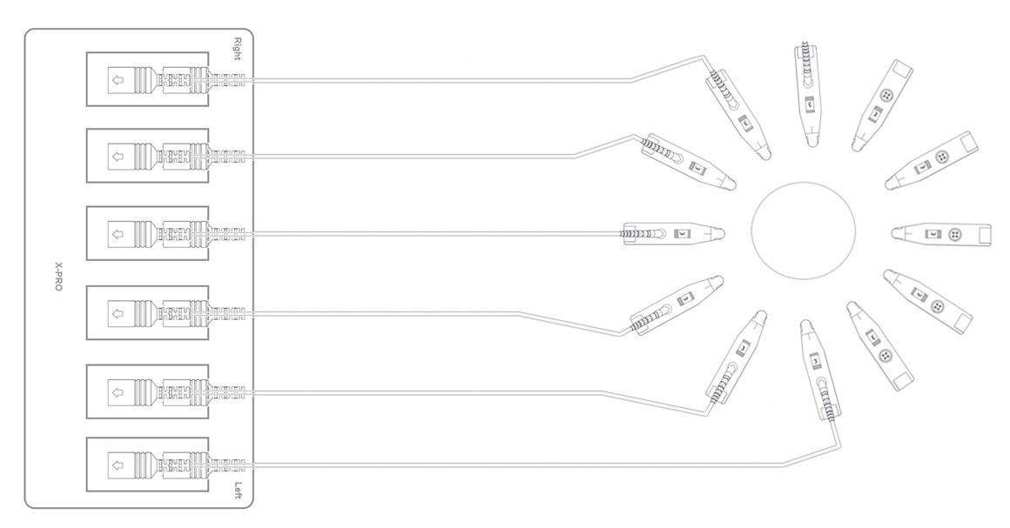

Technical Specifications

LO-PRO 3, Audial Comparative Hearing Aid Choice and Adaptation Device

Computer Communication : | Connection with USB interval unit
Feeding Type: | 200-240 V AC 50/60 Hz.
Power Max: | DC 12V,3A
Dimentions: | LxWxH ;41x18x6 cm
Weight : | 1,5 kg
Body Structure: | Plastic

System Requirements
Minimum Computer Requirements
-Pentium PC;
-RAM 512 MB
-USB Connection Point Available
-1024 x 600 Solubility
-Colour Number 16 Bit

Supported Operating Systems
-Microsoft Windows XP
-Microsoft Windows Vista 32-Bit
-Microsoft Windows 7 Professional /Ultimate

Operating Medium

Medium
Don’t use LO-PRO 3 in the mediums of flammable or forming of flammable substence concentration

Temperature
LO-PRO 3 is has been designed safely to operate between 0 and 40° C’.The heat conditions exceeding these limits can effect the safety.

Moisture
LO-PRO 3 has been designed to operate at moisture level of maximum %85 moisxture concentration

Using LO-PRO 3 Opening and Interface
LO-PRO 3 has software keeping facilities and infroming for user in the field of hearing health in front plan. The details about How to use LO-PRO 3 Interface are explained in this section, Set up files can be used to loading LO-PRO 3 Programmes by downloading from the web site www.dogusmedikal.com.tr
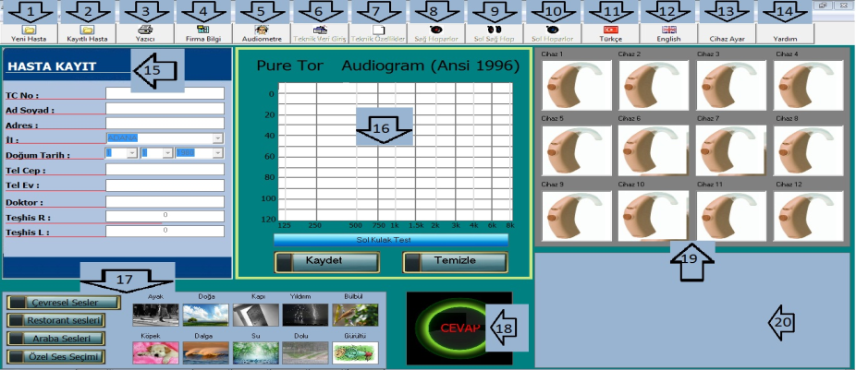

1. New Customer Record  2. Reaching to information of recorded customer  3. Printing  4. Access Page of Firm Information  5. Activating Audiometer Draft Box  6. Enrolling technical information of hearing aides  7. Enrolling technical documents of hearing aides  8. Closing right Headphone  9. Opening Right and Left Headphones  10. Closing Left Headphone | 11.Turkish language choice  12. English language Choice  13.Access to Adjusments of hearing aides  14.Access to help page  15. Area of Patient Record  16.Access area of Audiogram  17. Choice area of medium sounds  18. Button of Test Communication  19. Choice aarea of Hearin Aid  20. Area of Presenting information about Chosen Hearing aid

Explanation Interface Controlls;Controlls have been seperated to sections as between1 - 20 main control units,
their details are presented below

Figure 1: Explanation of Interface Controls

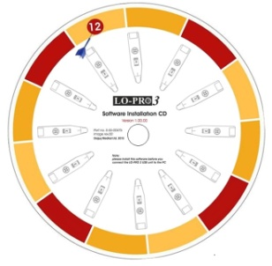  Tick the icon on the table, Other files necessary for programme operation are prepared during this time  Figure 2: Preliminary Opening Screen | 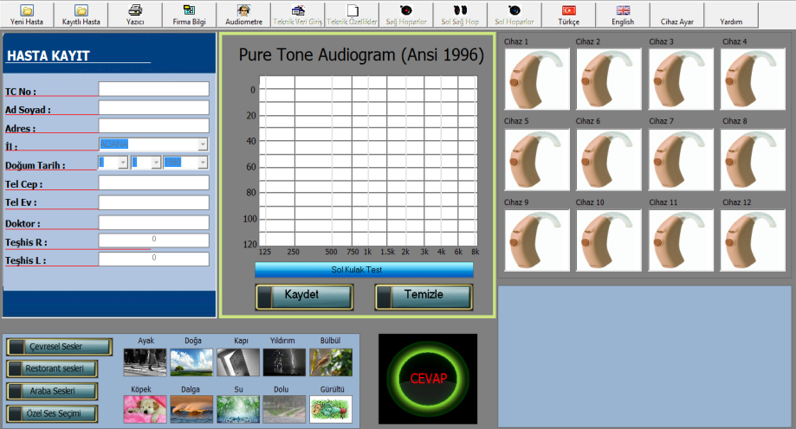  Patient enrollment section of operation interface consists of controls of Hearing aid area, audio draft, medium choice, medium sound choice and reaching to other pages  Figure 3: Opreation Interface

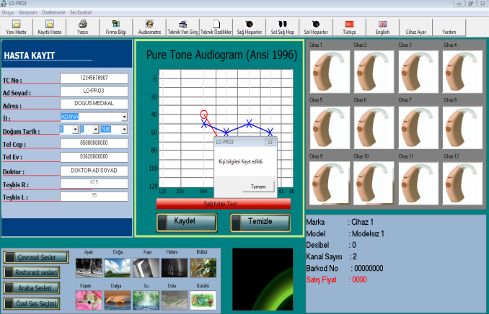

Customer Record Unit is the area of enrollment of identity information of patient with hearing loss whom the device will be applied, and the section of Access for TR-ID No, name surname, address, city, date of birth, phone number (home,work, cell) and name and information of phycian recommending hearing aid to the patient. If personal record process has been made indeficiency, the notify that personal information has been enrolledis appears on the screen. Personal information is filled indeficiency, additionally audiogram information of 16 persons and at least 500-1000-2000 and 4000 Hz values should be enrolled for right and lefte ar. After filling the necessary information, they are recorded.

Şekil 4: New Customer Record

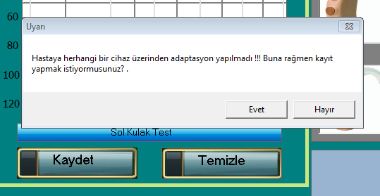  At the new patient unit, if deficient information is available, a warning like this can appear on the screen. You shoul read the warnings carefully, if you get this warning, it means that no adaptation has been made for the patient. In this situation, have the patient lkistened the sound of hearing aid by chosing a hearing aid after this step, you cannot meet a warning like this.  Figure 5: False Information Access | 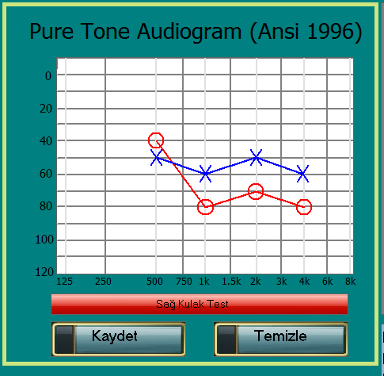  You can Access audiogram data of your patient in audio test into the above section. When you press to red right ear test buton, you can enter audiogram data of right ear and when you repress to blue left ear buton, you can enter audiogram data of left ear of your patient.  Şekil 6: Entrance of Audiogram Data

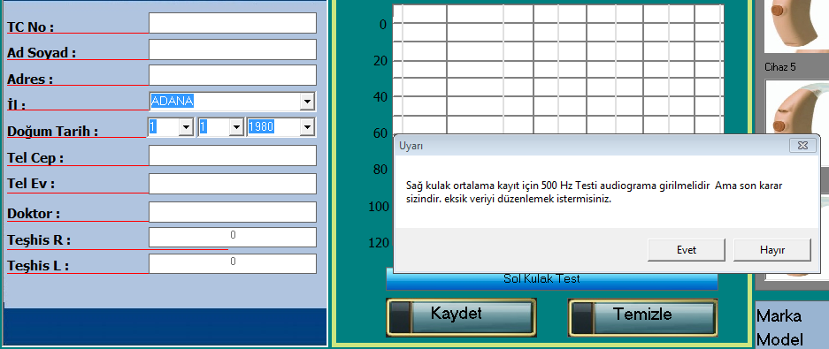  After entering audiogram data, by pressing record buton, if you enter deficient data, you can meet the warning like that on trhe screen  Şekil 7: Deficient Entrance of Audiogram Data | 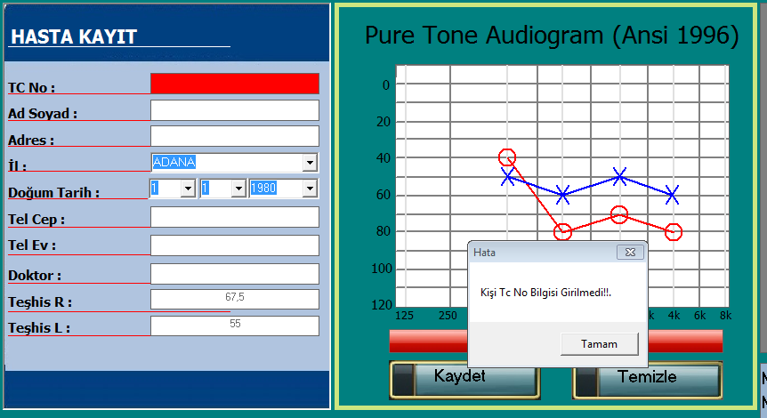  When you enter deficient customer information, you go on the process, you choose the hearing aid, you enter audiogram, you will get the above warning, The parts unsuitable to record are informed by red colour and warning message, Repress record button by completing and entering deficient information  Şekil 8: Deficient Entrance of Customer’s Record

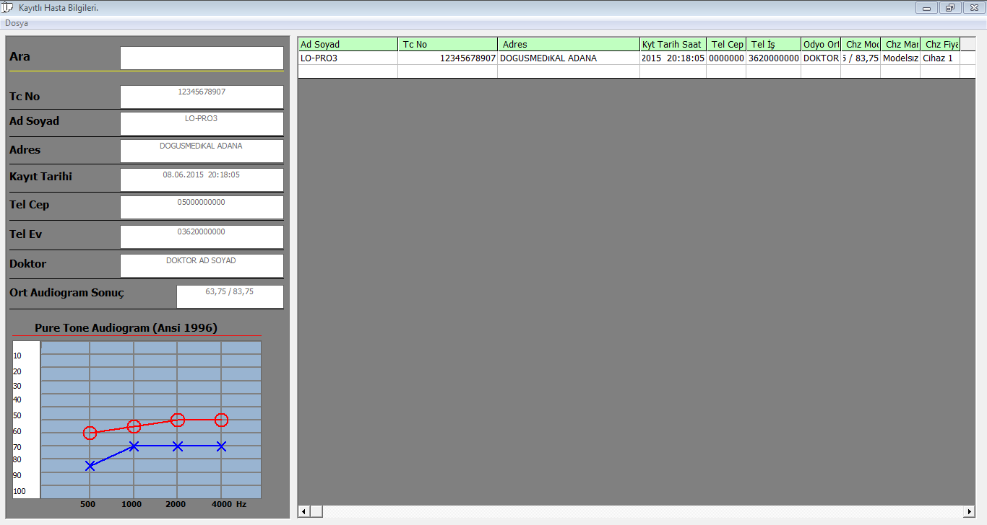  If the information of recorded patients are recorded in excell format on your computer, you can get output in excell format, additionally your can see audiogram data of the information belonging the patient in the left buttom part of the form.  Figure 9: Recorded Patient Information Form | 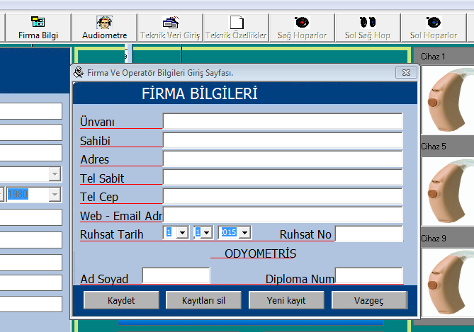  When you press the tabs of firm, the above form will be opened. In case of filling and recording te empty parts in the form, when you have it printedFirma bilgi sekmesine bastığınızda yukardaki form açılacaktır, the infomation can be seen on the form of hearin aid choice  Figure 10: Entering the firm Information

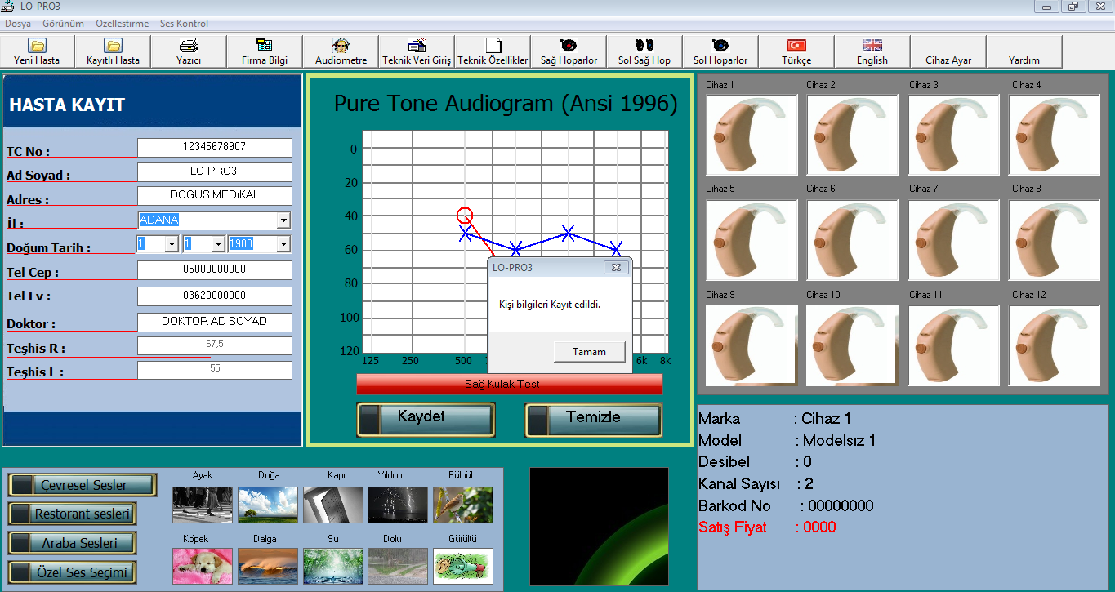  You can pass to the part of hearing aid choice after tou have recorded customer’s information and audiogram data. There 12 pieces hearing aid on the part of hearing aid choice. Hearing aid chosen will be active on cyclical hearin aid panel on LO-PRO 3 device. The light of chosen hearing aid will be on. The data (such as brand, model, decibel, channel number, barcode no and sale price) can be seen the part under hearing aid..  Figure 11: Hearing Aid Choice Part | You can have the patient listened the medium sounds, restaurant sounds, car sounds or any other sound you determine on the computer by choosing its file on the computer in the passing form from device during hearing aid choice by headphones.  Figure 12: Presenting Sound to Hearing Aides

In order to hear the sound quality of hearing aides well, you can go into calibration setting, For examble, you can minimize the whisper sounds coming into your ear by making calibration  Figure 13: Calibration Setting | This the form in which technical data of hearing aides are entered. You can identify the brands, models, powers (dB), cahnnel numbers, barcode numbers, serial numbers and other specifications when you place onto the cyclical panel of hearing adies. Output also includes the identified data.  Figure 14: Technical Data of Hearing Aides

All replies except for Error taken from Connection test shows the operating system. Operate LO-PRO 3 Programme forms loaded range. It is necessary to operate the programme as operator at Windows Vista and Windows 7 operating systems, you can provide this by coming on the programme and ticking the right and choosing operate as operator.

Data of patients recorded at LO-PRO 3 are in the excell format. Don’t forget regularly to take spares every month. All data in the local disc are deleted, when the system goes up. Please tow the important information before going up. Previously loaded softwares will be slow, when the disc section is started for the first time. Please wait for a while. The system speed will turn to normal when it is opened for the second time.

